IPPS
West Midlands and Wales
Visit to the National Arboretum, Westonbirt and Melcourt at Tetbury
We started our tour of The National Arboretum with a visit to their newest attraction, a Treetop Walkway. This superb structure allows you to walk from ground level into the tree canopy. The walkway has many well-designed interpretation boards explaining the science of trees and was very engaging and unusual way to explore the arboretum.
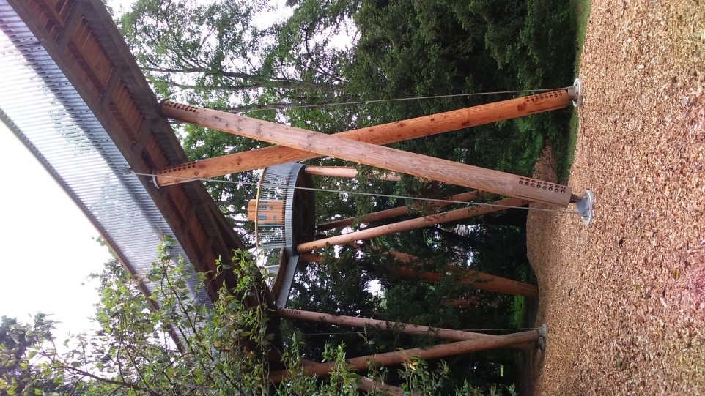
From the treetop walkway, we walked up to the nursery past several interesting and endangered trees such as Sorbus maderensis. Penny Jones, the propagator, gave us a tour of the renovated propagation nursery. The main aim of the propagation unit is to ensure that the diversity within the collection is maintained and expanded.
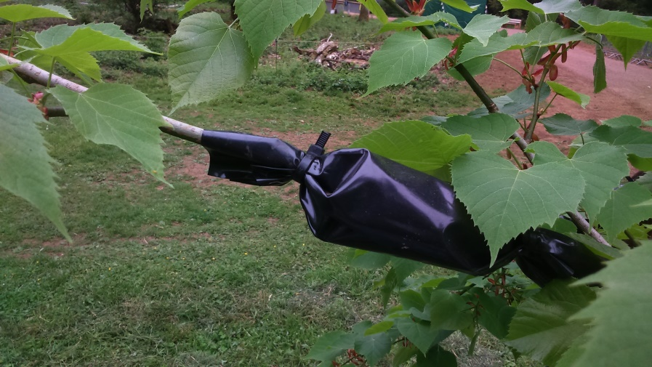
Most of the propagation work at Westonbirt involves vegetative propagation, as it is the particular genotypes that we are interested in. The work mainly involves cuttings and grafting. Penny was able to show us examples of air-layering in progress including Tilia in situ in out in the collection.

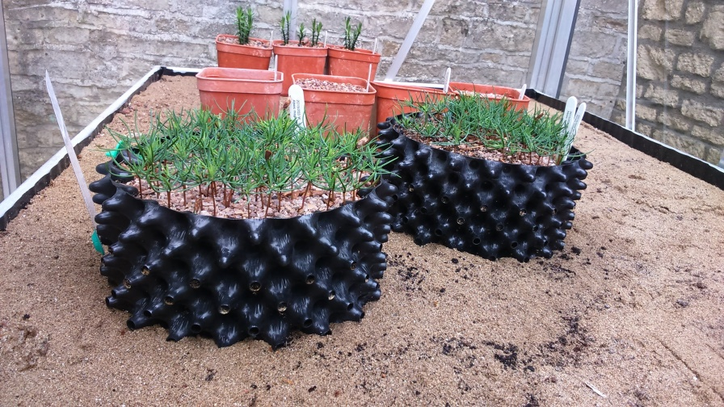
Westonbirt are always looking for wild source material and partake in seed collecting trips with partner organisations regularly. A recent collection trip brought hickories (Carya) from the USA. Many cultivars from the collections are propagating to continue the heritage of some of the rarest plants. The unit has sand beds for raising seeds and a tented misting system for cuttings. Bio security is a high priority for the nursery; disinfection mats are used at all entry points and there is a specific quarantine house.
It was a short hop to Melcourt who kindly fortified us with a sandwich lunch. Neil Gray was our host for the afternoon. We were shown a presentation on how Melcourt had developed their ranges and as a company. The range of peat free growing media and growing media ingredients was seen afterwards as we toured the production facility. In the yard were large windrows of bark compost of varying grades, white wood chip was the largest grade down to the smallest grade of pine bark.
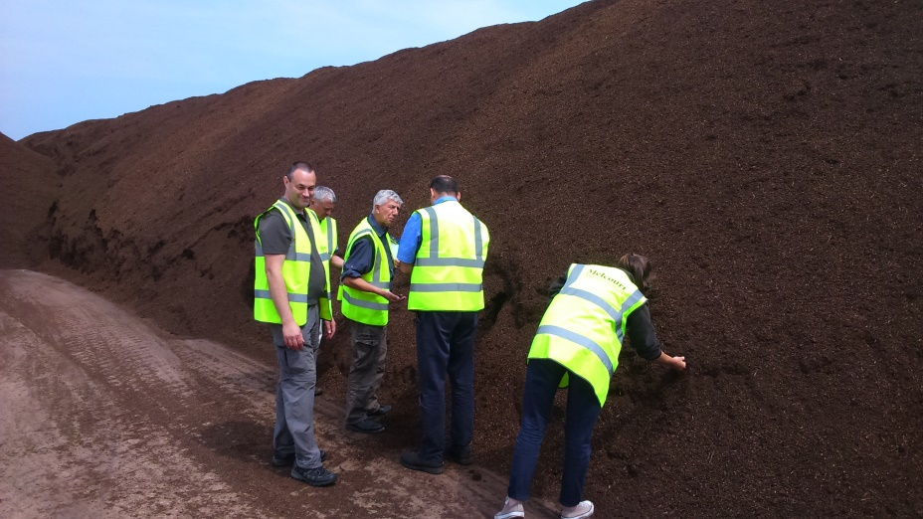
All these windrows were very hot beneath the outer surface due to microbial activity. Interestingly, the coir, with no microbial activity, was cooling beneath the surface.
These ingredients were fed into the production unit via sensor-controlled hoppers. 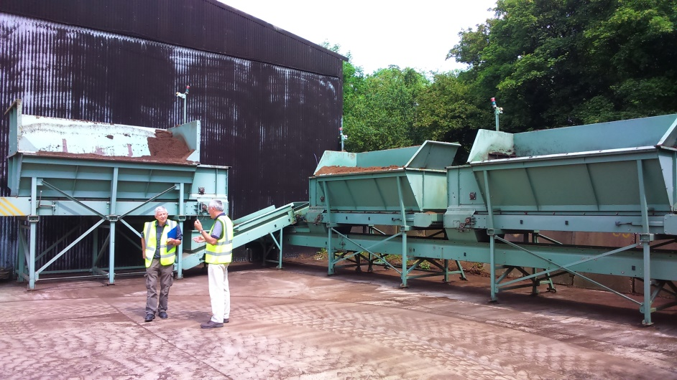
Further ingredients such as Met 52 and fertilisers are added before mixing. Once mixed, batch samples are taken for quality control and traceability. Growing trials are carried out on batches to ensure the quality of the growing media for sustaining plant growth. This was an interesting visit and would a good addition to a peat bog and growing media factory tour to gain a full insight into the growing media industry.
Thank you to Penny Jones of The National Arboretum Westonbirt, the Forestry Commission and Neil Gray of Melcourt Industries Ltd for their time before and during the visits.
The next meeting is on the 20th October 2016 to Batsford Foundation and Arboretum. Please contact the area secretary Vicki Wright (vickiwright112@gmail.com) or on 07786 625768 if you would like any additional information.

