Herbaceous Unrooted Cutting Husbandry

William Healy

Senior Technical and Research Manager, Ball Horticultural Company, West Chicago Illinois 60185, USA

Abstract.

During the last 20 years, the Floriculture industry has seen an exponential growth of vegetatively propagated plants originating from off-shore production locations. With the growth of off-shore production, the need to manage URC post-harvest life is critical to insure uniform establishment of root liners. We have investigated the role of relative humidity (RH) on post-harvest performance of a wide range of species currently available for sale. Uniform and rapid root development occurs when unrooted cuttings (URC) are fully hydrated prior to sticking, regardless of hydration status upon arrival at the rooting location. The best hydration treatment was removal of URC from all packaging and placing in a RH controlled (90-99%) cooler at 8C. Leaving URC in the plastic bag, but out of the shipping containers, was acceptable if there was enough time (12-24 hours) in a RH controlled chamber to fully hydrate the URC. The worse treatment that resulted in poor, uneven and reduced rooting was the current practice of placing URC in a non-RH controlled chamber at 8C without packaging. Once URC were stuck, the first 5-7 days required high RH to maintain URC turgidity. Rooting speed was optimized when the duration of the on-cycle was controlled to maintain foliage moisture without increasing the soil moisture to saturation. Optimizing the dry and wet soil moisture target weights were critical factors for promoting callus formation with lower dry target weights needed to promote uniform root growth throughout the soil profile.

**Introduction.**

Prior to the 1990’s the vegetatively propagated products used in Floriculture consisted of a narrow range of species that were first introduced as early as the beginning of the 20th century. The number of genera was limited and the varieties within each genus consisting of 1-100s of unique varieties. Growers would produce their own stock plants each season and harvest then root the unrooted cuttings (URC) as needed for their own or local requirements.

During the early 2000’s, commercial breeding companies began to aggressively introduce new genera and varieties with improved floriferousness, basal branching and consumer appeal. Concurrent with the introduction of the new varieties, large off-shore producers began supplying growers around the world with URC which eliminated the need for onshore self-propagation stock plants. The first challenge the off-shore producers addressed was the need to manage the cold chain from harvest to arrival at the rooting location. Managing the cold chain has improved over the last 20 years but still is a significant challenge due to gaps in the transport chain where temperature control is lost, and URC are exposed to fluctuating temperatures.

The off-shore URC supply chain produces a more uniform performing URC than did self-propagators. Unfortunately, the off-shore producers periodically ship URC that won’t root uniformly. There is no apparent reason why the URC failed to perform. The poor performance is unpredictable depending on various conditions, but ultimately resulted in reduced liner yield compared to the URC shipped. Rooting trials that evaluated chemical treatments, rooting media and misting intervals periodically reduced losses, but did not eliminate the inconsistent rooting performance. We have followed ‘inconsistent rooted’ liners though the production supply chain from rooting station to retail outlets. These ‘inconsistent rooted’ liners usually resulted in substandard plants at retail with a significant loss in retail value. Recognizing the lost sales opportunities, our research group of interns and grower cooperators asked the question “What factors can we operationally manipulate to improve not only speed of rooting but also uniformity?” We know from work on seed raised plugs that improving the uniformity of the population significantly improves final sales value at retail. Our current research focused on the role of hydration on URC performance from the time of receipt until roots began to form.

**Trials and Results**

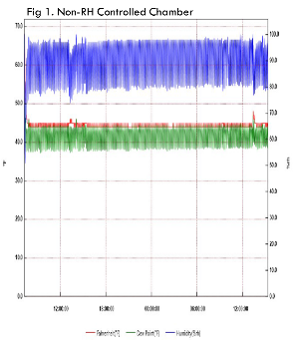Trial 1. Our initial trials assumed that off-shore URC could be re-hydrated like cut flowers where cut stem bases are placed in saturated soil conditions to facilitate water uptake to maintain hydration. Several trials were conducted to look at different media and saturation levels. No trial resulted in consistent rooting improvements or re-hydration of the URC. We determined that although placing URC directly in water would result in re-hydration, it was not possible to maintain saturated conditions in soil at the base of the URC to facilitate hydration.

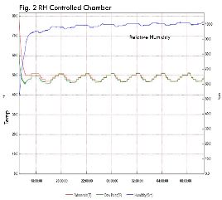Trial 2. We evaluated the relative humidity (RH) in the holding chamber (8C) to determine if we were hydrating or de-hydrating the URC when we had to hold the URC overnight. Fig. 1 shows the 13-hour oscillation of the temperature (green line), RH (blue line) and dew point (red line) in a chamber with no RH control. The RH varied between 80% to 100% which resulted in an oscillating vapor pressure deficit (VPD) of 0 to -0.2. Due to the continued accumulation of the -0.2 VPD there is a slow but steady drying out of the URC. This can be verified by looking at the condensation on the inside of the bag in the picture to the left. This moisture is moving from the URC to the air and then due to cool temperatures the water vapor condenses on the bag surface

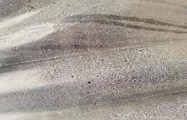

When we created a RH controlled chamber in the cooler, we observed a more consistent RH and temperature (Fig. 2) compared to the non-RH controlled chamber. Due to the lower VPD accumulation, the URC were able to absorb moisture from the air and became fully hydrated. We concluded that the cooler could create an elevated VPD which could cause dehydration of the URC. The longer the URC were held in the non-RH chamber the greater the dehydration of the URC.

Trial 3. To test the effect of chamber RH, we created a 2x2 trial of +/- RH versus URC in/out of bag. The ‘-RH+Bag’ (ambient RH + URC left in bag) is the current process while ‘+RH No Bag’ (added RH + URC removed from bag and exposed to elevated RH conditions) would be the treatment that creates the best hydration condition. The most stressful condition should be the ‘-RH no bag’.

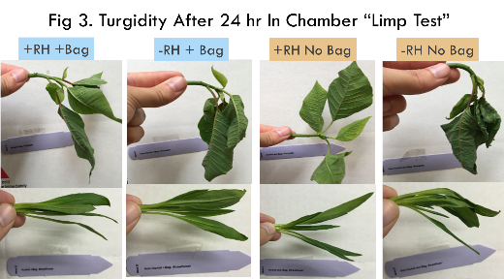Fig. 3 demonstrates the degree of hydration by looking at the turgidity of the leaves and stems. In a separate trial we quantified the amount of dehydration and leaf turgidity. The ‘-RH No Bag’ would be <70% full hydration while the ‘+RH No Bag’ would be at full hydration. The other treatments would be at various % of full hydration. It is interesting to note that the ‘+Bag’ treatments never reached full hydration or were <70% hydration after 24 hours in the chamber due to the bag providing a barrier to minimize the effect of the accumulated VPD in the chamber. Therefore, to maximize hydration there needs to be air exchange when bags are used to encourage re-hydration. An alternative we have used when RH controlled chambers are not available is to wrap the URC in wet paper towels and then place in bags. This increases the RH in the bag, and we observe fewer dehydrated URC at the time of sticking.

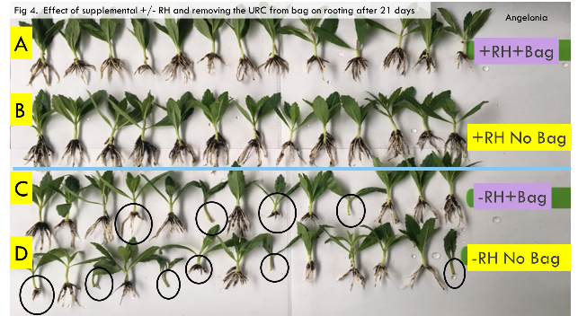Trial 4. We were interested in how the URC in trial 3 rooted. We stuck the URC from trial 3 and evaluated them 21 days later for root development and uniformity. Multiple species were trialed with similar results to what is shown in Fig 4. The best hydration treatment (B) clearly had more roots and greater uniformity than either the current process (C) or the most stressful treatment (D). It is interesting to note that the best treatment (B) and second most uniform (A) are slightly different in the root number and root length. Based on this trial we are beginning to understand that hydration is the primary factor which influences uniformity of rooting in herbaceous URC.

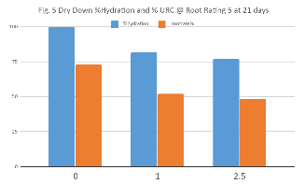Trial 5. Since hydration is a critical factor in predicting rooting performance, we investigated the effect of time between removal from the +RH chamber and sticking on URC hydration. We previously determined that the high essential oil crops, which have significant rooting and shoot breakdown problems, arrived at 24-60% dehydration. We observed that once the URC reached 75+% hydration rooting was impacted and <75% hydration levels resulted in marginal leaf collapse. Table 1 shows what happens when the URC are moved from a RH chamber to the sticking area and held for different durations before moving to a high RH environment. After 1 hour the URC drops to ~80% hydration and by 2.5 hours this continues to drop to almost 70%. When we look at maximum root development (Fig 5) we can see that % rooting uniformity drops from 75% to 50% as the time out of RH chamber increases. Therefore it is crtical that the URC are held in the RH chamber for as long as possible or held at the sticking area under high RH to prevent a decline in rooting uniformity and speed. When setting up a rooting area it is better to have the area on the right vs the area on the left which is way too dry and will cause hydrated URC to decline in performance. The grower on the right is able to hold stuck URC overnight with an observed improvement in performance. During the day, the URC are held for several hours in the high RH before moving into the rooting area. By holding at high RH prior to moving to the rooting area they are able to assure hydrated URC that insure uniform rooting and faster root development.

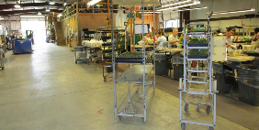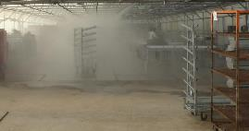

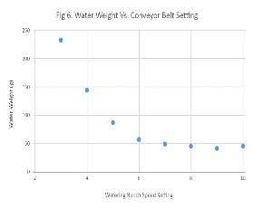Trial 6. Previous trials showed that rooting was directly related to the soil moisture. If the soil at the time of sticking was too dry or too wet then rooting was delayed. We have worked with growers to develop tray weight targets that will optimize callus formation and subsequent root development. A trial was done to determine the optimum belt speed for the watering tunnel to insure optimum moisture levels. Fig 6. Shows the effect of belt speed and the tray moisture levels. This intuitive observation is critical for growers to understand. The importance of setting up the sticking line to prevent saturated trays can’t be over stressed since saturated trays delay rooting. Each grower needs to determine the optimum tray weight to achieve a level 4 moisture which appears to be optimum for callus formation.

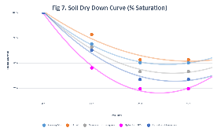Trial 7. We have observed different dry down rates of the media used in propagation systems as measured by how rapidly they reach different target weights (% full saturation). This is a critical piece of information to determine the correct mist settings. We believe that callus formation requires the soil to stay >80% saturation (level 4) but root development is best at 50% (level 2) and rewetting to 80%. Fig. 7 shows the dry down curves of the industry standard (Ellepots-orange) and several other media including the newest entry in the market ‘Hydrafiber’ (pink). Note that Hydrafiber drops to <80% saturation within 16 hours which would restrict callus formation if not misted aggressively. Conversely Ellepots remain >80% for up to 40 hours so managing the misting duration would be critical to prevent saturating the soil. To maximize root formation and development growers need to understand the dry down curves of their media and adjust the mist cycles to provide the correct targett moisture.

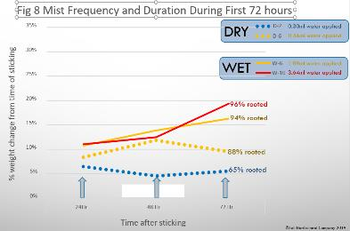Trial 8. The final trial was designed to evaluate the effect of misting duration and frequency during the first 72 hours on re-hydration and rooting. To determine the optimum response we used 2 different VPD mist frequency settings (O.5 and 1.5) when the mist ‘on’ cycle would be triggered. We then used different ‘on’ durations (2-14 sec) to provide different quantities of water every 24 hours. The amount of water applied is documented in Fig 8. The maximum rooting occurred at 21 days when the wet VPD frequency (0.5) was applied with eith 6 or 10 seconds of mist. When <0.6 ml or >1.2 ml of water per 24 hours was applied daily during the first 72 hours, rooting was affected. The data showed that there is an optimum frequency and duration that growers must determine to optimize root development in the shortest period possible. There are a number of factors that influence the mist settings and each grower must determine the optimum settings for their media and species.

**Discussion**

Based on our research trials and grower validation trials, we feel confident to recommend growers install VPD controlled RH systems in their holding coolers and sticking operations. We find that growers who try to use low pressure mist systems or wet floors to raise the RH, never achieve the same results that growers who install a high-pressure system. An effective high-pressure system can be purchased for USD$2-5,000 depending on size of cooler and rooting areas. Considering the weekly value of the URC in the cooler and rooting area, an improvement of 5% in root development and uniformity can provide a rapid ROI that continues for years to come.

Managing the soil moisture after sticking and during the first 72 hours in the greenhouse, is critical to insure continued hydration of the URC and promotion of callus formation. Growers can rapidly establish the correct targets for growth by using the ‘water by weight’ process developed by the author. By aggressively managing the target weights growers can achieve 1-2 weeks faster rooting (level 5 root development) and more uniform rooting within the production block. Disease issues were also reduced when growers used water by weight to target the optimum moisture which naturally reduced excess wet soil and foliage.

We have seen significant improvements in order fulfillment and plant quality when growers implement a robust URC husbandry program. Many of the ‘recommendations’ that are used in the industry become irrelevant when the URC hydration is correctly managed. Historically we had sticking sequence with many varieties on a ‘stick immediate’ recommendation. When the hydration is managed these ‘stick immediate’ URC can be held 1-2 days in high RH conditions with improved performance. URC husbandry is one of the last procedures that rooting operations must implement to improve their overall performance.