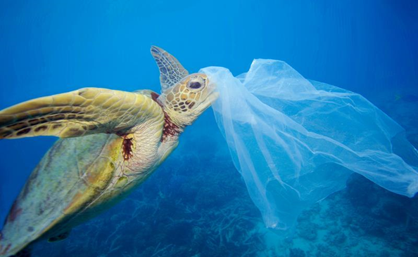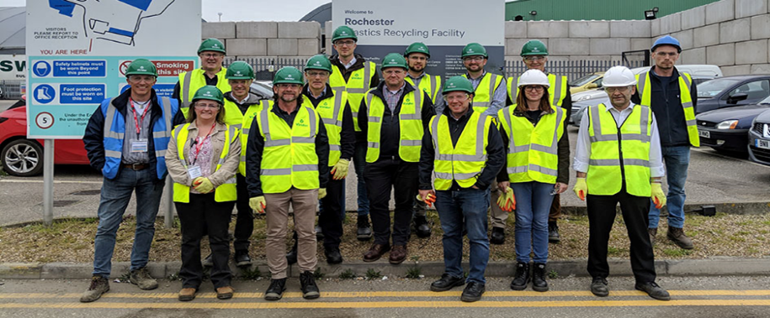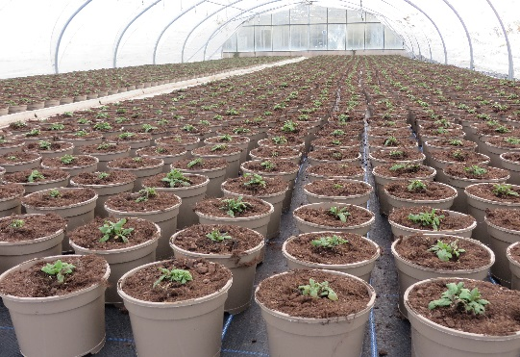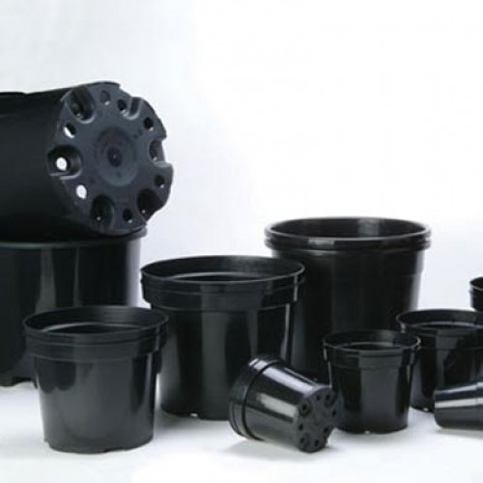[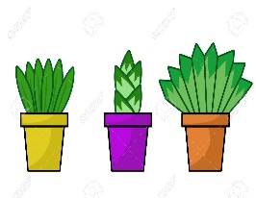](https://www.google.com/url?sa=i&rct=j&q=&esrc=s&source=images&cd=&ved=2ahUKEwjS8vTF2OnkAhVPXBoKHZmEDREQjRx6BAgBEAQ&url=https%3A%2F%2Fwww.123rf.com%2Fphoto_45987960_stock-illustration-plants-pot-cartoon-illustration.html&psig=AOvVaw2mxmqnpdRry0lZkh-U6muE&)

Alex Everett (Aeroplas UK) & David Chilvers (Bransford Webbs)

PLASTICS IN HORTIC LT RE

At the end of 2017 David Attenborough and the team at Blue Planet 2 brought the startling truth about our use of plastics into every living room in the country. The nation sat up and realised that we are dumping huge amounts of plastics into our rivers and oceans every day, and that we needed to act before it was too late. Alex Everett (Aeroplas) and David Chilvers (The Bransford Webbs Plant Company) highlight one way in which the Ornamentals Horticulture industry has led the way in a collaboration to develop one solution to help alleviate the problem.

The industry needed to find a solution that would meet all the demands of growing plants over very different growing periods in a multitude of environments and weather conditions, whilst being able to be used through mechanised potting methods and remaining economically viable.

Once the nursery industry woke up and realised that we needed to change our use of plastic, a group of some of the leading growers to the retail market came together to develop a joint approach. In what is seen as an industry leading collaboration these businesses put aside commercial advantage and worked together for the greater good of the industry and environment. This led to the birth of the taupe pot and a push to move all plant production to be in a kerbside recyclable solution as soon as possible.

Collaboration

Experts in the pot manufacturing industry had already seen the need to change. Alex and Aeroplas had been working on solutions to the problem as far back as 2014 , but it wasn't as simple as it sounds. Sourcing recycled carbon free, detectable polymer wasn't easy. Fortunately new sources were discovered and volumes grew. To produce consistent colours you need to add masterbatch and this also contained carbon pigment so Alex had to work with these suppliers to provide a solution. By early 2018 Aeroplas had a product that was ready to show customers.

The Solution

The Challenges

For many years the horticulture industry has used black poly-propelene and expanded polystyrene as its main material to hold compost for growing. These materials have served the industry well and provide a versatile and robust product that can stand up to the rigours of plant production through all seasons and fit with increasingly mechanised systems. Black plastic (usually polypropylene in the case of pots) is cheap because it can contain many different colours or recycled material that are then blended with carbon black to produce a uniform colour. The sorting automation within UK recycling facilities use Near InfraRed scanners to grade out plastic containing carbon black so the pots are generally discarded to landfill or energy recovery. This means that although they have been made from recycled material and are potentially recyclable, in reality they become single use as the consumer cannot recycle them easily.

The problem