Smart IPM – Data Driven Decisions
Ant Surrage – Fargro

Integrated pest management (IPM) adoption has increased considerably within the horticultural sector across an array of crops and situations. The driving forces behind this are the increased resistance to and the loss of synthetic chemistry and increasing legislative and societal pressures. Couple this with an increase in investment in the development of alternative control methods and the increase in adoption becomes clear.

However, there are barriers for a grower to the adoption of IPM. Those principally being, control methods being less efficacious, less predictable and more complex. Many industries have grasped the concept of and seen the value in the data they collect, within horticulture and IPM, data offers significant value and potential to optimise programmes and reduce barriers to entry.

Growers primarily are interested in an "output" that is in this case improved efficacy from an IPM programme. Improved sensor technology can enhance the quality of the data set we put into a process by making it more representative, granular and consistent. Cloud-based computing systems then allow that higher quality data set to be better analysed, presented and collaborated upon which in turn leads to the insight from the data being of more value to the grower.

Controls within an IPM system, be they macrobiological or biopesticides, in a majority of cases, are living organism. As living organisms, they have adapted to perform optimally in certain environmental conditions. It is therefore extremely important that when applying controls a grower thinks about the environmental conditions and the impact this has on the pest or disease and the control method.

Take for example Beauveria bassiana, as either Naturalis - L or BotaniGard. B.Bassiana, when used in the correct environmental conditions, is capable of extremely efficient control of aphids, whitefly and a range of other pests. However, when used in cool, low humidity environments the efficacy is considerably lower. The ideal conditions for the fungus is between 20 - 30ºC and above 60% relative humidity (RH), with sporulation taking place above 80% RH.

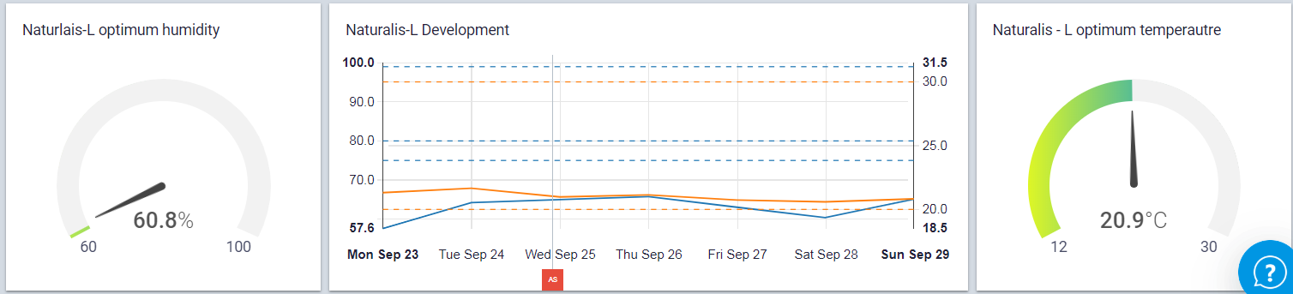
Fig 1. Image showing the environmental conditions required for Naturalis – L, showing current conditions in gauges that change colour based on conditions. With an additional line graph showing conditions over the last week with bands programmed in for the development conditions for B.bassiana. (Construct on ZENSIE).

Dashboards like the example shown in Fig. 1 translate this information in the form of gauges and graphs giving a grower insight into how well the fungus will perform at that moment, and also the environmental patterns give an indication of how well B.bassiana will perform over time. This concept can be applied to most if not all the control methods in an IPM programme, from macrobiologicals to conventional chemistry.

We can start to build on this foundation by using environmental data to help predict disease and pest outbreaks and help refine the application timing of control methods. For example, the fungus ampelomyces quisqualis is hyperparasite of powdery mildew. The fungus offers little curative action but as a hyperparasite requires powdery mildew to be present to survive. Therefore, there is a small window of opportunity to optimally apply the control to achieve maximum efficacy. By monitoring environmental conditions and programming alerts for risk of powdery mildew development growers can more confidently apply the product and can expect to see improve efficacy.

In summary, within an IPM system, there is a multitude of variables that are affected by environmental conditions, from lifecycle speeds of pests and diseases to feeding of macrobiologicals. It is therefore critical to the success of a programme that these conditions are properly monitored and insight from that data is easily transformed into actions that can help optimise the performance of an IPM programme.

